

**MALIGNANT COMMENTS CLASSIFICATION**

Submitted by:

SHAIK ALTHAFULLA

**ACKNOWLEDGMENT**

This includes mentioning of all the references, research papers, data sources, professionals and other resources that helped you and guided you in completion of the project.

References:  **Malignant comments classification**

Github.com

Towardsscience.com

Scikit-learn.org

Kaggle.com

Stackoverflow, etc

Research papers: The papers can be studied kaggle and github studies papers and links.

Professionals and other resources: Data trained analytics partner and FLIPROBO Data analyst company.

Data source: Social Media platforms

The data set contains the training set, which has approximately 1,59,000 samples and the test set which contains nearly 1,53,000 samples. All the data samples contain 8 fields which includes ‘Id’, ‘Comments’, ‘Malignant’, ‘Highly malignant’, ‘Rude’, ‘Threat’, ‘Abuse’ and ‘Loathe’.

The label can be either 0 or 1, where 0 denotes a NO while 1 denotes a YES. There are various comments which have multiple labels. The first attribute is a unique ID associated with each comment

**INTRODUCTION**

* Business Problem Framing

The proliferation of social media enables people to express their opinions widely online. However, at the same time, this has resulted in the emergence of conflict and hate, making online environments uninviting for users. Although researchers have found that hate is a problem across multiple platforms, there is a lack of models for online hate detection.

* Conceptual Background of the Domain Problem

Online hate, described as abusive language, aggression, cyberbullying, hatefulness and many others has been identified as a major threat on online social media platforms. Social media platforms are the most prominent grounds for such toxic behaviour.

* Review of Literature

Different data will be provided with words of

* **Malignant:** It is the Label column, which includes values 0 and 1, denoting if the comment is malignant or not.
* **Highly Malignant:** It denotes comments that are highly malignant and hurtful.
* **Rude:** It denotes comments that are very rude and offensive.
* **Threat:** It contains indication of the comments that are giving any threat to someone.
* **Abuse:** It is for comments that are abusive in nature.
* **Loathe:** It describes the comments which are hateful and loathing in nature.
* **ID:** It includes unique Ids associated with each comment text given.
* **Comment text:** This column contains the comments extracted from various social media platforms.

are there lot of analysis and eda process after increasing data sufficient accuracy points to evaluate the metrics and design model through NLP.

* Motivation for the Problem Undertaken

Our goal is to build a prototype of online hate and abuse comment classifier which can used to classify hate and offensive comments so that it can be controlled and restricted from spreading hatred and cyberbullying.

**Analytical Problem Framing**

* Mathematical/ Analytical Modeling of the Problem

The mathematical, statistical and analytics modelling done during this project along with the proper justification.

Using some of libraries in python pandas, Numpy, seaborn and matplotlib and some metrics used with NLP.

* Data Sources and their formats

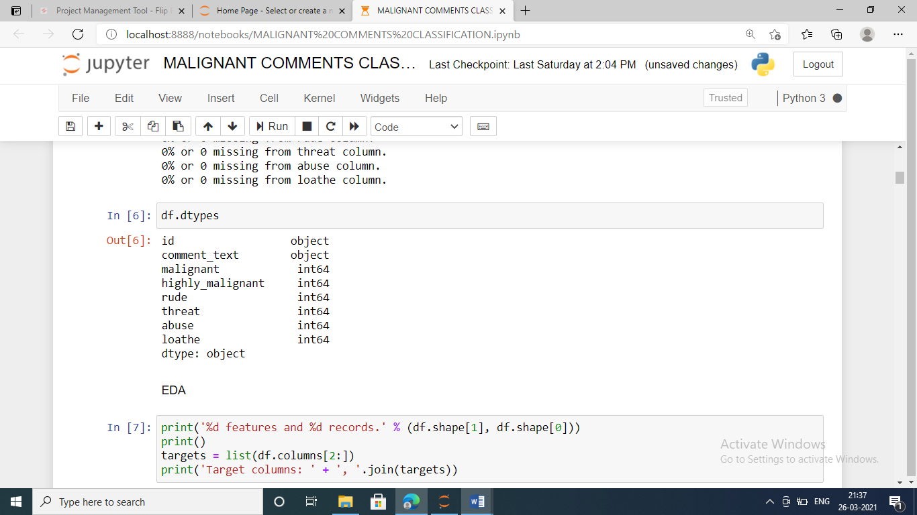

* Data Preprocessing Done

In this dataset there are no null values present train and test datasets.so EDA process can be done with with lot of procedure. The object oriented categorical data can be coverted by the valuable information. After analyse the describe method and metrics and model can be developed through NLP.

* Data Inputs- Logic- Output Relationships

Target columns: malignant, highly_malignant, rude, threat, abuse, loathe

* Hardware and Software Requirements and Tools Used
* **Python**
* **Pandas libraries**
* **Numpy libraries**
* **Seaborn libraries**
* **Matplotlib.libraries**
* **Scikit learn for import metrics to do macine learning**
* **NLP**

**Model/s Development and Evaluation**

* Identification of possible problem-solving approaches (methods)

The clear cut EDA process after cleaning the data to NLP

Applying check each input and label target output variables. Machine learning.

* Testing of Identified Approaches (Algorithms)

Nlp process can be done and also applied different algorithms

* Key Metrics for success in solving problem under consideration
* Classification Metrics (**accuracy**, precision, recall, F1-score, ROC, AUC).
* Visualizations

All distplot diagrams cleanly observed and analysed the data

* Interpretation of the ResultsThe visualization and preprocessing models variables are important to predict the data

**CONCLUSION**

* Key Findings and Conclusions of the Study

Data contains 8 features and 159571 records

* Data contains no Null values.
* Extensive EDA has to be performed.
* Data contains as categorical variable.
* Machine Learning models, apply regularization and determine the optimal values of Hyper Parameters.
* Learning Outcomes of the Study in respect of Data Science

The data can be algorithms is suitable to the guassian Nb

* Limitations of this work and Scope for Future Work

The data is increases the lot of visualization is different manner analysed

In algorithms to improve accuracy.